Practical No 13 & 14
VIII. Resources required (Additional)
→ If any web resources required.

Resources used (Additional)
→ https://www.tutorialspoint.com/vb.net/vb.net_regular_expressions.htm
→ https://docs.microsoft.com/en-us/dotnet/standard/base-types/regular-expressions
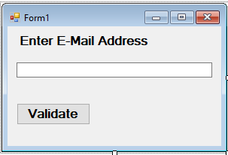→ https://docs.microsoft.com/en-us/dotnet/api/system.windows.forms.errorprovider

Program Code
  - Write a program using Error Provider and Regular Expression.
➢

Imports System.Text.RegularExpressions Public Class Form1

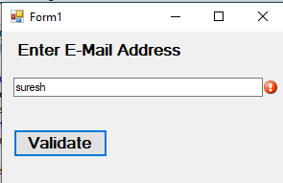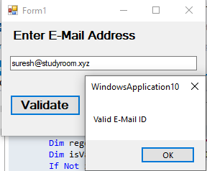
End Class
Private Sub Button1_Click(sender As Object, e As EventArgs) Handles Button1.Click
Dim regex As Regex = New Regex("^([\w-\.]+)@((\[[0-9]{1,3}\.[0-9]{1,3}\.[0-
9]{1,3}\.)|(([\w-]+\.)+))([a-zA-Z]{2,4}|[0-9]{1,3})(\]?)$")
Dim isValid As Boolean = regex.IsMatch(TextBox1.Text.Trim) If Not isValid Then
ErrorProvider1.SetError(TextBox1, "Invalid E-mail ID") Else
MsgBox("Valid E-Mail ID") End If
End Sub
XII. Results (Output of the Program)

Practical related Questions
  - Enlist the different constructs for Regular Expressions.
- Constructs for Defining Regular Expressions
There are various categories of characters, operators, and constructs that lets you to define regular expressions. Click the following links to find these constructs.
  - Character escapes
  - Character classes
  - Anchors
  - 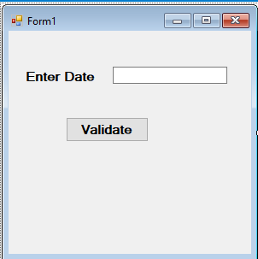Grouping constructs
  - Quantifiers
  - Backreference constructs
  - Alternation constructs
  - Substitutions
  - Miscellaneous constructs

Write the program code to perform validation using ErrorProvider Control.
➢

Imports System.Text.RegularExpressions Public Class Form1
Private Sub Button1_Click(sender As Object, e As EventArgs) Handles Button1.Click Dim regex As Regex = New Regex("(((0|1)[0-9]|2[0-9]|3[0-1])\/(0[1-9]|1[0-2])
\/((19|20)\d\d))$")
Dim b As Boolean = regex.IsMatch(TextBox1.Text.Trim) If Not b Then
ErrorProvider1.SetError(TextBox1, "Invalid Format") Else
MsgBox("Valid Format") ErrorProvider1.SetError(TextBox1, "")
End If End Sub
End Class

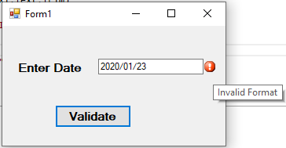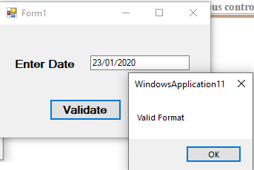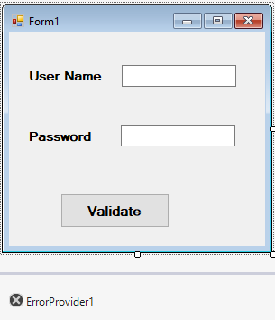OUTPUT:

- rcise
  - Write a program using ErrorProvider for username and password authentication.

Else
Public Class Form1

Private Sub Button1_Click(sender As Object, e As EventArgs) Handles Button1.Click If TextBox1.Text = "" Then
ErrorProvider1.SetError(TextBox1, "Please Enter Your Name") Else
ErrorProvider1.SetError(TextBox1, "") End If
If TextBox2.Text = "" Then
ErrorProvider1.SetError(TextBox2, "Please Enter Your Password")

ErrorProvider1.SetError(TextBox2, "") End If
End Sub End Class

OUTPUT:

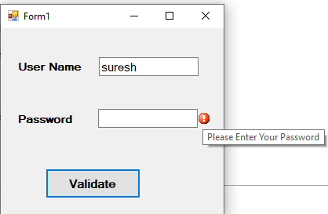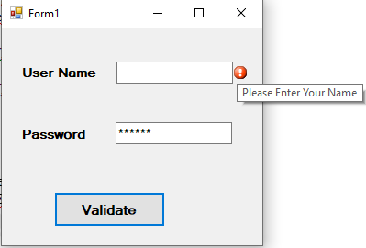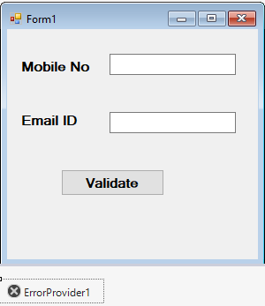
Else
2.
Write a program using ErrorProvider
Email ID in GUI appnlication.
for control to validate Mobile Number and
➢
Imports System.Text.RegularExpressions
Public Class Form1
Private Sub Button1_Click(sender As Object, e As EventArgs) Handles Button1.Click Dim number As New Regex("\d{10}")
If number.IsMatch(TextBox1.Text) Then ErrorProvider1.SetError(TextBox1, "") MsgBox("Valid Phone Number")

ErrorProvider1.SetError(TextBox1, "Invalid Phone Number") End If
Dim regex As Regex = New Regex("^([\w-\.]+)@((\[[0-9]{1,3}\.[0-9]{1,3}\.[0-
9]{1,3}\.)|(([\w-]+\.)+))([a-zA-Z]{2,4}|[0-9]{1,3})(\]?)$")
Dim isValid As Boolean = regex.IsMatch(TextBox2.Text.Trim) If Not isValid Then
ErrorProvider1.SetError(TextBox2, "Invalid E-mail ID") Else
ErrorProvider1.SetError(TextBox2, "") MsgBox("Valid E-Mail ID")
End If End Sub
End Class

OUTPUT:

